**PIZZA SALES SQL QUERIES**

**A. KPI’s**

**1. Total Revenue:**

select SUM(total_price) as Total_Revenue

from pizza_sales;

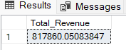

**2. Average Order Value**

select SUM(total_price)/COUNT(distinct order_id) as Avg_Order_Value

from pizza_sales;

**3. Total Pizzas Sold**

select SUM(quantity) as Total_Pizza_Sold

from pizza_sales;



**4. Total Orders**

select COUNT(distinct order_id) as Total_Orders

from pizza_sales;



**5. Average Pizzas Per Order**

select CAST (CAST( SUM(quantity) as decimal (10,2)) /

CAST( COUNT(distinct order_id) as decimal (10,2)) as decimal (10,2))

as Avg_Pizzas_Per_Order

from pizza_sales;

**B. Daily Trend for Total Orders**

select DATENAME(DW, order_date) as order_day,

COUNT (distinct order_id) as total_orders

from pizza_sales

group by DATENAME(DW, order_date)

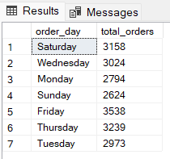

**C. Monthly Trend for Orders**

select DATENAME(MONTH , order_date) as Month_name,

COUNT(distinct order_id) as Total_orders

from pizza_sales

group by DATENAME(MONTH , order_date)

order by Total_orders desc;

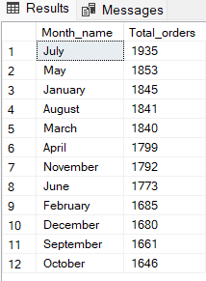

**D. % of Sales by Pizza Category**

select pizza_category , SUM(total_price)*100 / (select SUM(total_price) from pizza_sales) as PCT

from pizza_sales

group by pizza_category;

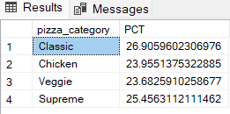

**E. % of Sales by Pizza Size**

select pizza_size, SUM(total_price)*100 / (select SUM(total_price) from pizza_sales) as PCT

from pizza_sales

group by pizza_size;

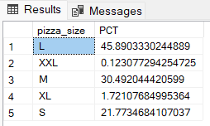

**F. Total Pizzas Sold by Pizza Category**

select pizza_category, SUM(quantity) as Total_Quantity_Sold

from pizza_sales

group by pizza_category

order by Total_Quantity_Sold desc

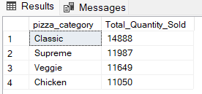

**G. Top 5 Pizzas by Revenue**

select Top 5 pizza_name, sum(total_price) as Total_revenue

from pizza_sales

group by pizza_name

order by Total_revenue desc;

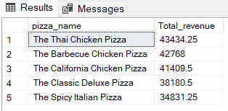

**H. Bottom 5 Pizzas by Revenue**

select Top 5 pizza_name, sum(total_price) as Total_revenue

from pizza_sales

group by pizza_name

order by Total_revenue asc;

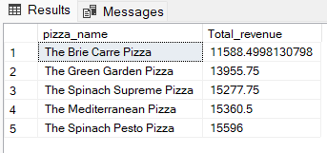

**I. Top 5 Pizzas by Quantity**

select top 5 pizza_name , sum(quantity) as Total_Pizza_Sold

from pizza_sales

group by pizza_name

order by Total_Pizza_Sold desc;

**J. Bottom 5 Pizzas by Quantity**

select top 5 pizza_name , sum(quantity) as Total_Pizza_Sold

from pizza_sales

group by pizza_name

order by Total_Pizza_Sold asc;

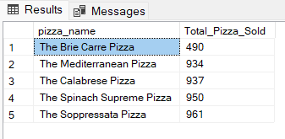

**K. Top 5 Pizzas by Total Orders**

select top 5 pizza_name , count(distinct order_id) as Total_Orders

from pizza_sales

group by pizza_name

order by Total_Orders desc;

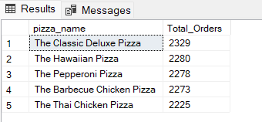

**L. Bottom 5 Pizzas by Total Orders**

select top 5 pizza_name , count(distinct order_id) as Total_Orders

from pizza_sales

group by pizza_name

order by Total_Orders asc;

